### Miniature House #5 - A Cape Cod with Extended V Front

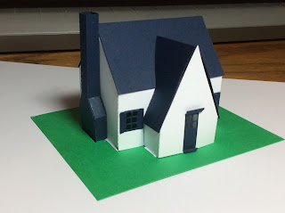

This miniature house is probably my favorite so far. I like the extended V front. I changed the window size to make them a little bigger. No glue is necessary for the windows or door. They are bent into the house with the tabs facing inward. The same is true for the door. Fold the perforations and bend the sides inward.

I recommend bending all of the tabs before inserting into their respective slot as it makes it easier to glue. I discovered that gluing the chimney to the house with a glue dot makes the task easier.

I used card stock. I just bought some from Michaels.

